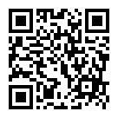
S301專用QR CODE 如右: OR https://forms.gle/eLkKokyTV1Nybk9q9

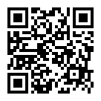
S302專用QR CODE 如右: OR https://forms.gle/6R53ERGbTGBxrCcL7

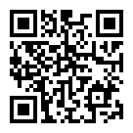
S303專用QR CODE 如右: OR https://forms.gle/uQYnKzWm68BQt87TA

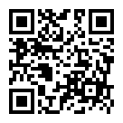
S304專用QR CODE 如右: OR https://forms.gle/cdmUJfd1Gb2JHWxx9

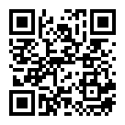
S305專用QR CODE 如右: OR https://forms.gle/kqx6gqf8W8rtuMiY9

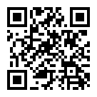
S306專用QR CODE 如右: OR https://forms.gle/1WtSkTvnF7Pvu2WS6

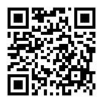
S307專用QR CODE 如右: OR https://forms.gle/R5x5HAsBiZSmYqb77

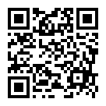
S308專用QR CODE 如右: OR https://forms.gle/gceLUjSsBjRDzVED6

